**Question** : Explain the difference between Java Persistence API, Hibernate and Spring Data JPA

When working with Java-based applications that need to interact with databases, you’ll often hear about **JPA**, **Hibernate**, and **Spring Data JPA**. While they’re closely related, each one plays a different role in the persistence layer. Let’s break them down clearly.

### **Java Persistence API (JPA)**

**JPA** is simply a specification—it defines a standard way to manage relational data in Java. It’s part of the official Java EE (now Jakarta EE) stack and provides a set of rules and annotations for mapping Java objects to database tables. But JPA doesn’t do anything by itself. It doesn’t have any actual code or engine behind it.

### **Hibernate**

**Hibernate** is an actual working library, a popular ORM (Object-Relational Mapping) tool that implements the JPA specification. It came before JPA even existed, and once JPA was introduced, Hibernate adapted to support it fully.

### **Spring Data JPA**

**Spring Data JPA** makes life even easier—especially for Spring developers. It builds on top of JPA and Hibernate to abstract away much of the repetitive boilerplate code.

With Spring Data JPA, you no longer need to write your own EntityManager logic. Instead, you can just define a repository interface like UserRepository, extend JpaRepository, and Spring will automatically generate the implementations for common operations like save(), findAll(), findByEmail(), etc.

It also supports JPQL, native SQL queries, pagination, sorting, and even custom queries via annotations. All while keeping your code clean and minimal.

**Main Differences**

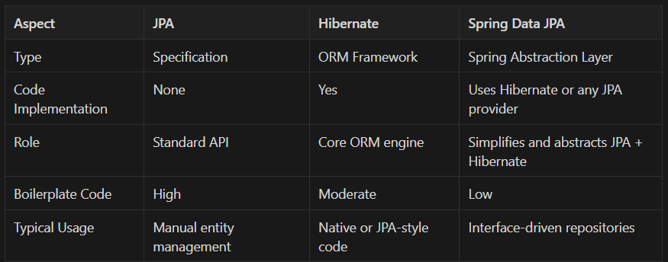

In most modern Spring Boot applications, these three work together under the hood. You, as the developer, typically interact with **Spring Data JPA**. Behind the scenes, it relies on **JPA** interfaces and uses **Hibernate** as the default provider.

So while they serve different purposes, they’re all part of the same ecosystem—just different layers of abstraction built to make database interaction more structured, powerful, and developer-friendly.